**MODELOS**  
 **Synthetica Classy Look and Feel**

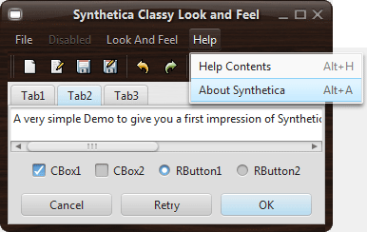  
 **Synthetica BlackEye Look and Feel**  
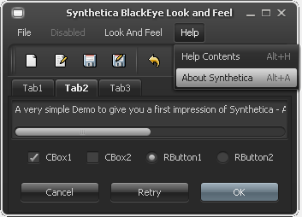

**Synthetica Simple2D Look and Feel**

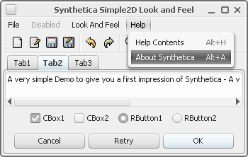

**Synthetica WhiteVision Look and Feel**

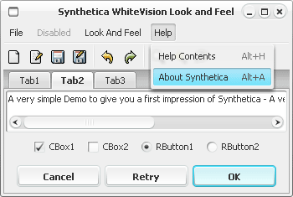

**Synthetica SkyMetallic Look and Feel**

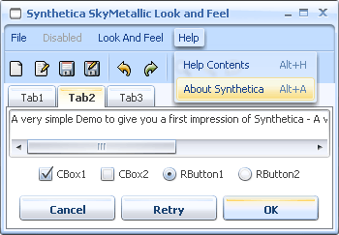

**Synthetica OrangeMetallic Look and Feel**

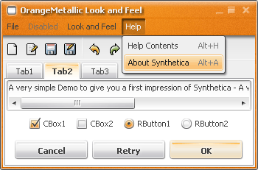

**Synthetica BlueSteel Look and Feel**  
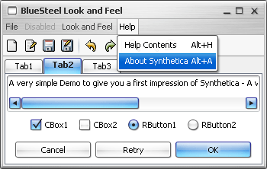

**Synthetica BlackMoon Look and Feel**

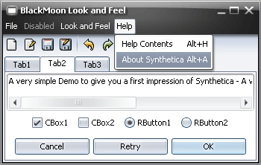

**Synthetica BlueMoon Look and Feel**

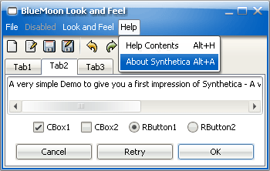

**Synthetica SilverMoon Look and Feel**  
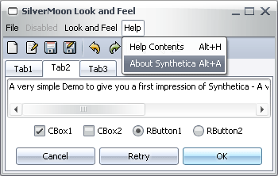  
 **Synthetica BlueIce Look and Feel**  
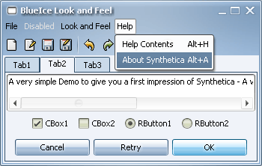

**Synthetica GreenDream Look and Feel**

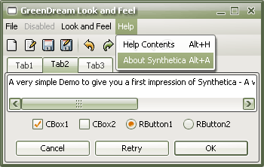

**Synthetica BlackStar Look and Feel**  
